Ex.No : 1(a) | MongoDB – CRUD operations, Indexing, Sharding, Deployment
Date: | MongoDB – CRUD operations, Indexing, Sharding, Deployment
AIM:

To Create MongoDB database using various objects like CRUD operation, Indexing Sharding and Deployment on Student DB
DEFINITION : MONGODB
MongoDB, the most popular NoSQL database, is an open-source document-oriented database. The term ‘NoSQL’ means ‘non-relational’. It means that MongoDB isn’t based on the table-like relational database structure but provides an altogether different mechanism for storage and retrieval of data. This format of storage is called BSON ( similar to JSON format).
A simple MongoDB document Structure:
{
title: 'Geeksforgeeks',
by: 'Harshit Gupta',
url: 'https://www.geeksforgeeks.org',
type: 'NoSQL'
}
SOFTWARE REQUIRED:
SNO | SOFTWARE | REQUIRED
1. | MongoDBCompass | COMMAND PROMPT

PROCEDURE:

Step 1:Go to startwindow search MongoDB compassClick the same and create database shown in below,

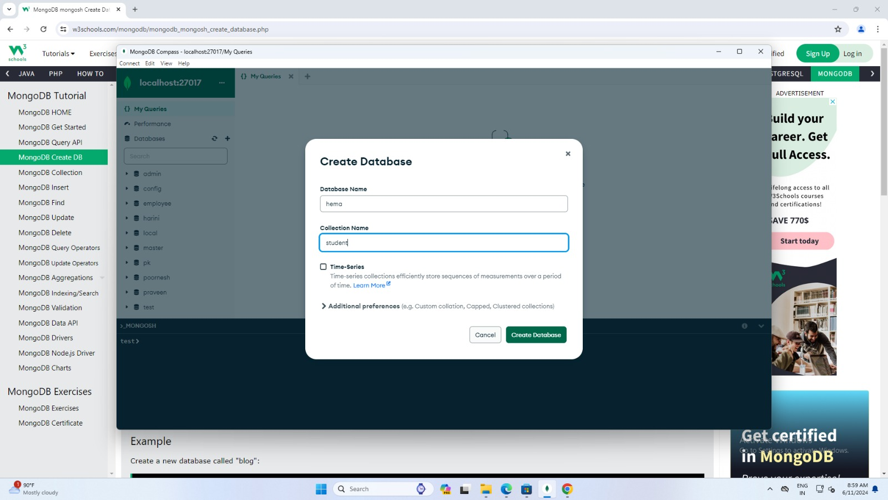

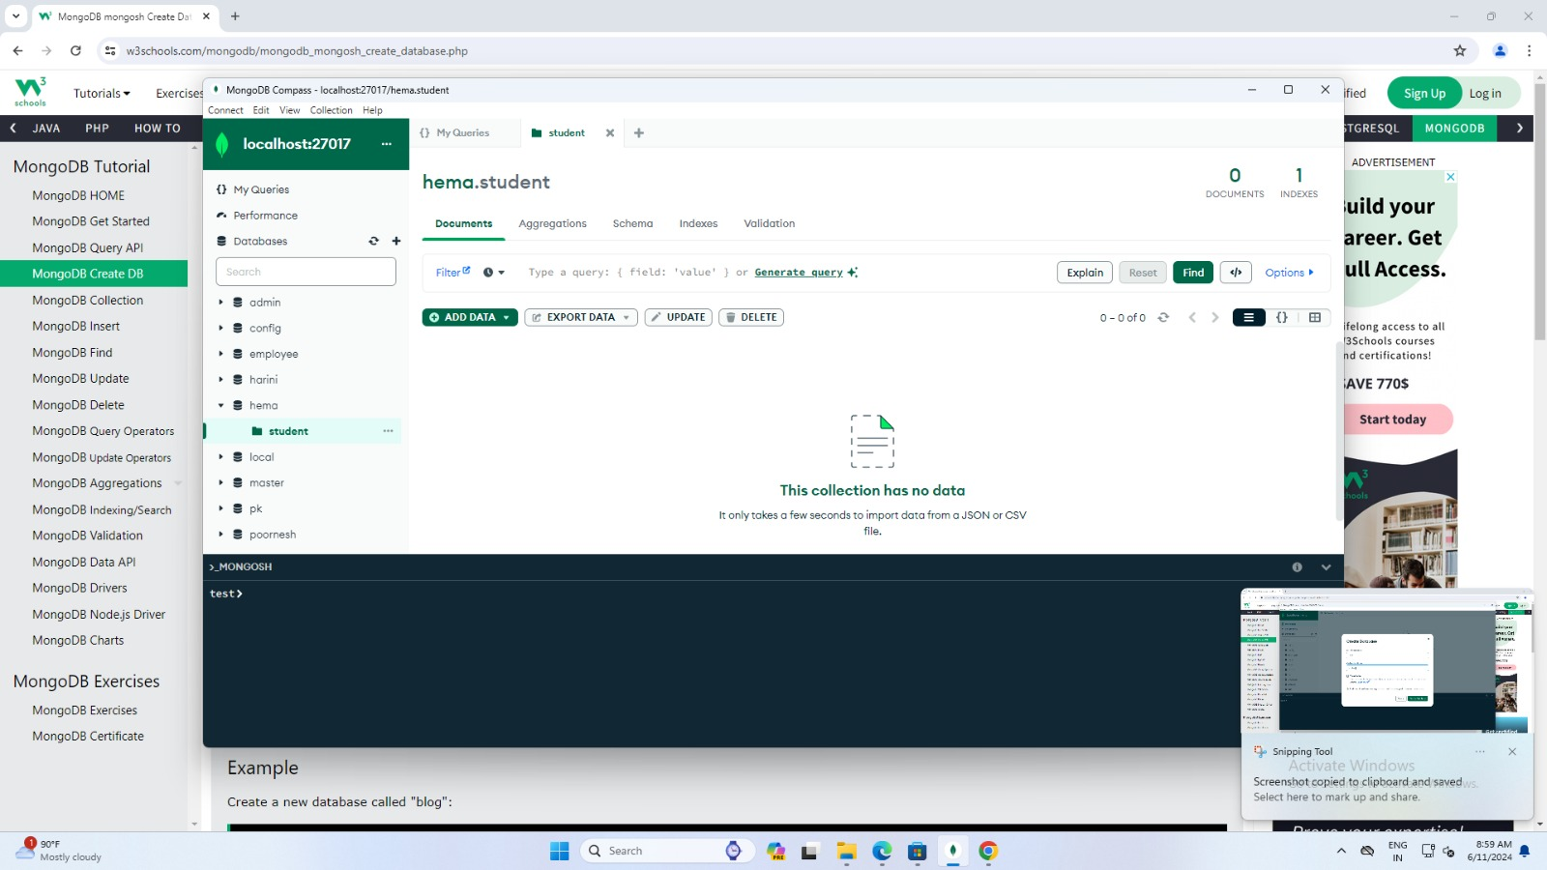

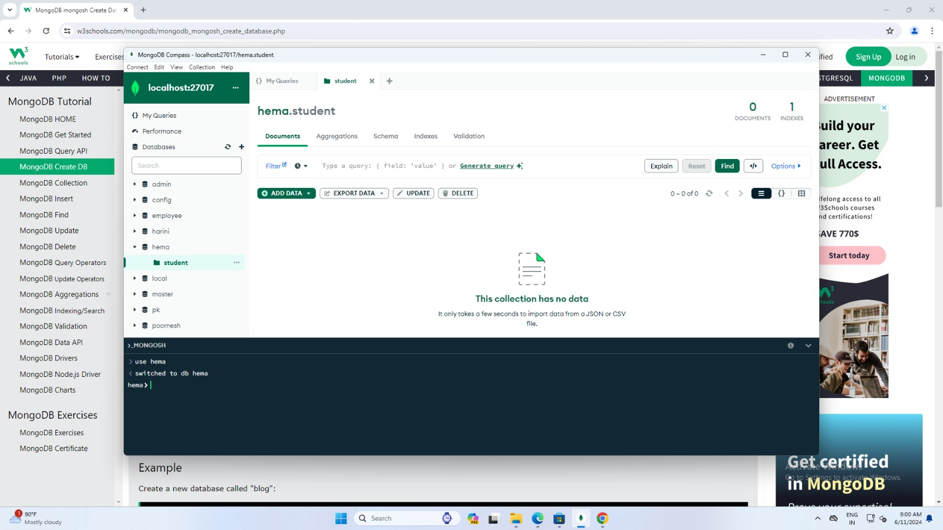

Step 2:Refer above screen shows command prompt for upcoming steps to proceed.

---The use Command

MongoDB use DATABASE_NAME is used to create database. The command will create a new database if it doesn't exist, otherwise it will return the existing database.

Syntax:
Basic syntax of use DATABASE statement is as follows −
use DATABASE_NAME

Example:
If you want to use a database with name <cahcet>, then use DATABASE statement would be as follows −
>use cahcet
switched to db cahcet

>show dbs
local 0.78125GB test 0.23012GB

---The dropDatabase() Method
MongoDB db.dropDatabase() command is used to drop a existing database.

Syntax:
Basic syntax of dropDatabase() command is as follows −
db.dropDatabase()

Example:
First, check the list of available databases by using the command, show dbs.
>db.dropDatabase()
>show dbs
local 0.78125GB test 0.23012GB
>

---The createCollection() Method
MongoDB db.createCollection(name, options) is used to create collection.

Syntax:
Basic syntax of createCollection() command is as follows −
db.createCollection(name, options)

Examples:
Basic syntax of createCollection() method without options is as follows −
>use cahcet
switched to db cahcet
>db.createCollection("student")
{ "ok" : 1 }
>

---The drop() Method
MongoDB's db.collection.drop() is used to drop a collection from the database.

Syntax:
Basic syntax of drop() command is as follows − db.COLLECTION_NAME.drop()

Example:
First, check the available collections into your database mydb.
>use cahcet
switched to db cahcet
>db.student.drop() true
>
Again check the list of collections into database.
>show collections mycol system.indexes

---The insert() Method
To insert data into MongoDB collection, you need to use MongoDB's insert() or save() method.

Syntax:
The basic syntax of insert() command is as follows −
>db.COLLECTION_NAME.insert(document)

Example:
> db.student.insert({
... regno: 510820622302,
... name: "raj",
... dept: "mca",
... sem: 01,
... })
WriteResult({ "nInserted" : 1 })
>

> db.student.insertMany(
[
{
regno: 510820622301,
name: "kumar",
dept: "mca", sem: 01,
},
{
regno: 510820622302,
name: "murugan", dept: "mca",
sem: 01,
},
{
regno: 510820622303,
name: "rajkumar", dept: "mca",
sem: 01,
}
] )

{
"acknowledged" : true, "insertedIds" : [
ObjectId("5dd631f270fb13eec3963bed"), ObjectId("5dd631f270fb13eec3963bee"), ObjectId("5dd631f270fb13eec3963bef")
]
}

---The find() Method
To query data from MongoDB collection, you need to use MongoDB's find() method.

Syntax:
The basic syntax of find() method is as follows −
>db.COLLECTION_NAME.find()
> db.student.find()
{ "_id" : ObjectId("5dd4e2cc0821d3b44607534c"), "regn" : "510820622301, "name" : "raj", "dept" : "mca", "sem" : "01"}
>

---The pretty() Method
To display the results in a formatted way, you can use pretty() method.

Syntax:
>db.COLLECTION_NAME.find().pretty()

Example:
Following example retrieves all the documents from the collection named mycol and arranges them in an easy-to-read format.
> db.student.find().pretty()
{
"_id" : ObjectId("5dd4e2cc0821d3b44607534c"), regno: 510820622302,
name: "murugan", dept: "mca",
sem: 01,
}

---MongoDB Update() Method
The update() method updates the values in the existing document.

Syntax:
The basic syntax of update() method is as follows −
>db.COLLECTION_NAME.update(SELECTION_CRITERIA, UPDATED_DATA)

Example:
>db.student.update({'name':'raj’},{$set:{'name':'RajA'}}) WriteResult({ "nMatched" : 1, "nUpserted" : 0, "nModified" : 1 })

---The remove() Method
MongoDB's remove() method is used to remove a document from the collection. remove() method accepts two parameters. One is deletion criteria and second is justOne flag.

Syntax:
Basic syntax of remove() method is as follows −
>db.COLLECTION_NAME.remove(DELLETION_CRITTERIA)

Example:
Db.student.remove({'name':'raj'}) WriteResult({"nRemoved" : 1})

---The createIndex() Method
To create an index, you need to use createIndex() method of MongoDB.

Syntax:
The basic syntax of createIndex() method is as follows().
>db.COLLECTION_NAME.createIndex({KEY:1})

Example:

>db.student.createIndex({"title":1})
{
"createdCollectionAutomatically" : false, "numIndexesBefore" : 1,
"numIndexesAfter" : 2,
"ok" : 1
}
>

---Deployment mongostat
This command checks the status of all running mongod instances and return counters of database operations. These counters include inserts, queries, updates, deletes, and cursors. Command also shows when you’re hitting page faults, and showcase your lock percentage. This means that you're running low on memory, hitting write capacity or have some performance issue.

D:\set up\mongodb\bin>mongostat
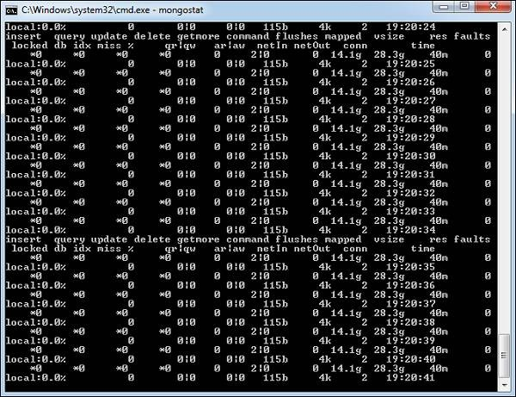
mongotop
This command tracks and reports the read and write activity of MongoDB instance on a collection basis. By default, mongotop returns information in each second, which you can change it accordingly. You should check that this read and write activity matches your application intention, and you’re not firing too many writes to the database at a time, reading too frequently from a disk, or are exceeding your working set size.

D:\set up\mongodb\bin>mongotop
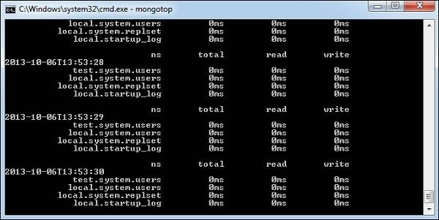

RESULT:
Thus,the MongoDB – CRUD operations, Indexing, Sharding, Deployment has been successfully executed.

